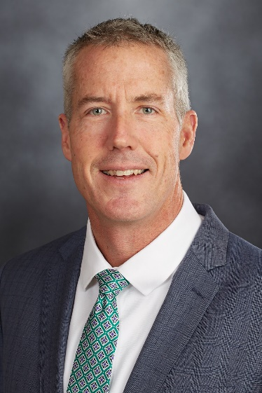

Jay Hennessey

Vice President, Learning and Development

Jay is beginning his 2nd season with the Cleveland Indians as Vice President of Learning and Development for Baseball Operations. In this role, Jay serves as a resource for leaders at all levels to continuously improve through leadership development and learning management initiatives.

Prior to joining the Indians, Jay served 25 years in the United States Navy. Jay finished his career serving as the Commander of the Naval Special Warfare Center, overseeing the selection, training and qualification for all Navy SEALS, before retiring as a Captain.

A Connecticut native, Jay earned a Bachelor of Arts degree from Villanova University, a Master’s of Business and Administration from San Diego State University and was a distinguished graduate of the U.S. Naval War College, earning a Master’s of Arts Degree in National Security and Strategic Studies.

Jay and his wife Jessica reside in Westlake Ohio with their four children.

